Assignment-2
Name: Kavitha B
Reg no: 192565041
Course: DSA0106

Q1 – Call by Value, Call by Reference and Call by Pointer
- Explanation
Call by value, reference and pointer are three ways of passing variables to a function.

Method | Meaning | Changes original variable?
Call by Value | Passes a copy | No
Call by Reference | Passes an alias | Yes
Call by Pointer | Passes the address | Yes
Example: Hostel fee = ₹45,000 and concession = 10%.
  - Call by value: Changes only the local copy.
  - Call by reference: Changes the original fee.
  - Call by pointer: Uses the address to change the original fee.

UML diagram
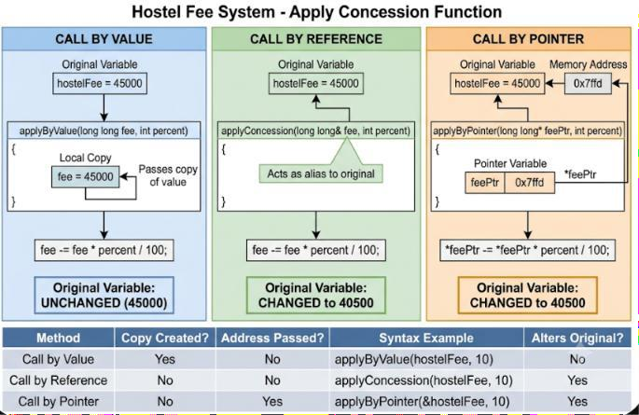

Predication code:

#include <iostream> using namespace std;

void change(int a, int& b, int* c)
{
a += 10;
b += 10;
*c += 10;
}

int& bigger(int& p, int& q)
{
return p > q ? p : q;
}

void show(int x, int y = 5, int z = 10)
{
cout << x + y + z << ' ';
}

int main()
{
int a = 1, b = 2, c = 3;

change(a, b, &c);

cout << a << ' ' << b << ' ' << c << '\n';

bigger(a, c) = 100;

cout << a << ' ' << c << '\n';

show(1);
show(1, 2);
show(1, 2, 3);

cout << '\n';

return 0;
}

Output
1 12 13
1 100
16 13 6

Pseudocode
START

SET fee = 45000

CALL applyByValue(fee, 10) PRINT fee

CALL applyByReference(fee, 10) PRINT fee

CALL applyByPointer(fee, 10) PRINT fee

STOP
- Simple C++ program

#include <iostream> using namespace std;

void applyByValue(long long fee, int percent)
{
fee = fee - (fee * percent / 100);
}

void applyByReference(long long &fee, int percent)
{
fee = fee - (fee * percent / 100);
}

void applyByPointer(long long *fee, int percent)
{
*fee = *fee - (*fee * percent / 100);
}

int main()
{
long long fee = 45000;

applyByValue(fee, 10);
cout << "After value: " << fee << endl;

applyByReference(fee, 10);
cout << "After reference: " << fee << endl;

applyByPointer(&fee, 10);
cout << "After pointer: " << fee << endl;

return 0;
}

Output
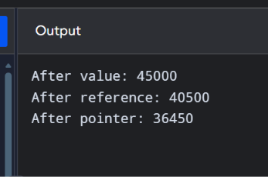
Explanation of output:
  - Value: The original fee remains ₹45,000.
  - Reference: 10% concession reduces the fee to ₹40,500.
  - Pointer: Another 10% concession reduces ₹40,500 to ₹36,450.

Testing table

Test | Input fee | Method | Expected result
1 | 45000 | Value (10%) | 45000
2 | 45000 | Reference (10%) | 40500
3 | 40500 | Pointer (10%) | 36450
4 | 10000 | Reference (25%) | 7500

Complexity analysis

Method | Time complexity | Extra space
Call by value | O(1) | O(1)
Call by reference | O(1) | O(1)
Call by pointer | O(1) | O(1)
For a long long, the copied parameter occupies a fixed amount of memory. For a large Student object, passing by value copies the entire object, whereas reference and const reference avoid that copy.

Comparison:

Comparison point | Prediction code | Original assignment program
Purpose | What the predicted program is expected to do | What the given assignment program is designed to do
Functions | Functions written in the prediction | Functions provided or required in the assignment
Logic | Logic used in the prediction | Logic used in the original program
Variables | Variables used | Variables used
Output | Predicted result | Actual expected result after completing the assignment

Alternative code:
#include <iostream> using namespace std;

double calculateDiscount(double fee, double percent)
{
return fee - (fee * percent / 100);
}

int main()
{
double fee = 50000;

double newFee = calculateDiscount(fee, 10);

cout << "Original fee: " << fee << endl; cout << "New fee: " << newFee << endl;

return 0;
}

output:

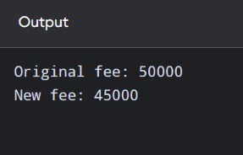

Q2 – Return by Reference and Its Dangers
- Explanation
Returning by reference means a function returns access to an existing variable instead of returning a separate copy.
For example, if a function returns the highest mark by reference, the caller can directly modify that mark.
Three types:
  - Return by reference: Allows modification.
  - Return by const reference: Allows reading but prevents modification through the returned reference.
  - Return by value: Returns a separate copy.

UML diagram

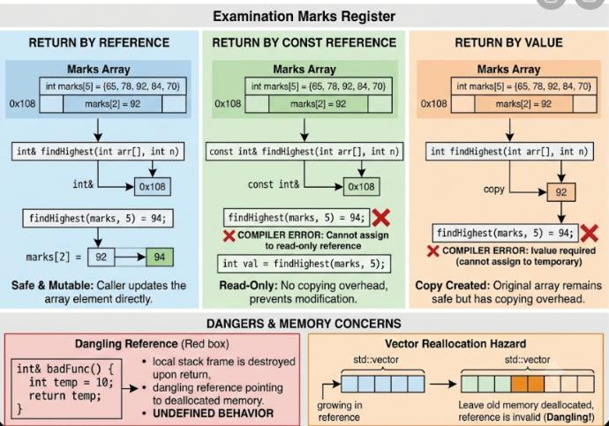
- prediction code: #include <iostream> using namespace std;

int& highestMark(int marks[], int n)
{
int maxIndex = 0;

for(int i = 1; i < n; i++)
{
if(marks[i] > marks[maxIndex])
{
maxIndex = i;
}
}

return marks[maxIndex];
}

int main()
{
int marks[5] = {75, 89, 92, 80, 85};

cout << "Highest mark: "
<< highestMark(marks, 5) << endl;

highestMark(marks, 5) += 2;

cout << "After moderation: ";

for(int i = 0; i < 5; i++)
{
cout << marks[i] << " ";
}

cout << endl;

return 0;
}

output:
Highest mark: 92
After moderation: 75 89 94 80 85

Pseudocode
START

CREATE marks array

SET highest = first element

FOR each mark in array IF mark > highest
UPDATE highest END IF
END FOR

RETURN reference to highest element

ADD 2 to returned mark

DISPLAY updated array

STOP
- Simple C++ program

#include <iostream> using namespace std;

int& highestMark(int marks[], int n)
{
int maxIndex = 0;

for(int i = 1; i < n; i++)
{
if(marks[i] > marks[maxIndex])
{
maxIndex = i;

}
}

return marks[maxIndex];
}

int main()
{
int marks[5] = {75, 89, 92, 80, 85};

cout << "Highest mark: " << highestMark(marks, 5) << endl;

highestMark(marks, 5) += 2;

cout << "After moderation: ";

for(int i = 0; i < 5; i++)
{
cout << marks[i] << " ";
}

return 0;
}

Output
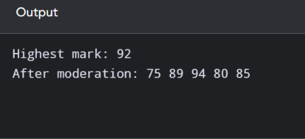

Testing table

Test | Marks | Expected highest | After +2
1 | 75, 89, 92, 80, 85 | 92 | 94
2 | 60, 70, 80, 90, 95 | 95 | 97
3 | 40, 50, 60, 70, 80 | 80 | 82

Dangerous reference example
int& wrong()
{
int x = 50; return x;
}
This is incorrect because x is a local variable. It is destroyed when the function ends. Returning a reference to it creates a dangling reference, and using that reference causes undefined behaviour. A compiler may warn about this.
Alternative:
- Index: Return the position of the highest mark and modify marks[index].
- Pointer: Return the address of the highest mark and modify *pointer.

Complexity analysis

Operation | Time Space
Find highest using reference | O(n) O(1)  O(n) O(1)  O(n) O(1)
Find highest using index | O(n) O(1)  O(n) O(1)  O(n) O(1)
Find highest using pointer | O(n) O(1)  O(n) O(1)  O(n) O(1)

comparision:

Feature | Prediction code | Original assignment code
Function names | change() | applyByValue(), applyByReference(), applyByPointer()
Parameters | Integer, reference, pointer | Fee and percentage
Operation | Adds 5 | Calculates 10% concession
Call by value | Uses a copy | Uses a copy of fee

Call by reference | Changes referenced variable | Changes original fee
Call by pointer | Changes value using address | Changes fee using pointer

Alternative code:
#include <iostream> using namespace std;

int& findMaximum(int arr[], int n)
{
int maxIndex = 0;

for(int i = 1; i < n; i++)
{
if(arr[i] > arr[maxIndex]) maxIndex = i;
}

return arr[maxIndex];
}

int main()
{
int arr[5] = {75, 89, 92, 80, 85};

int &maximum = findMaximum(arr, 5);

cout << "Maximum: " << maximum << endl;

maximum = 94;

cout << "Updated array: ";

for(int i = 0; i < 5; i++) cout << arr[i] << " ";

return 0;
}

output:
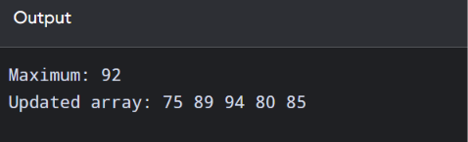

Q3 – Default Arguments and Function Overloading
- Explanation
Function overloading means creating multiple functions with the same name but different parameter types or numbers of parameters.
Default arguments are values automatically used when the caller does not provide all arguments. Example:
charge(2.5);
If express and insured are optional, their default values can be false.
The original three function declarations create ambiguity because charge(2.5) can match more than one overload.

UML diagram

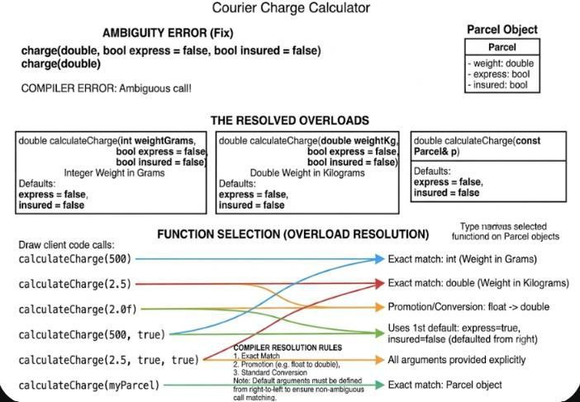

prediction code:
#include <iostream> using namespace std;

void charge(int grams)
{
cout << "Weight in grams: " << grams << endl;
}

void charge(double kg, bool express = false, bool insured = false)
{
int amount = 100;

if(express) amount += 50;

if(insured) amount += 50;

cout << "Courier charge: " << amount << endl;
}

struct Parcel
{
int weight;
};

void charge(Parcel p)
{
cout << "Parcel charge: 150" << endl;
}

int main()
{
Parcel p = {2000};

charge(2000); charge(2); charge(2.0);
charge(2.0f); charge(2.0, true); charge(p);

return 0;
}

output
Weight in grams: 2000 Weight in grams: 2 Courier charge: 100

Courier charge: 100
Courier charge: 200
Parcel charge: 150

Pseudocode
START

INPUT weight

IF weight is integer
CALL integer charge function ELSE IF weight is double
CALL double charge function ELSE IF input is Parcel
CALL Parcel charge function END IF

APPLY express charge if selected APPLY insurance charge if selected

DISPLAY total charge

STOP
- Simple C++ program

#include <iostream> using namespace std;

struct Parcel
{
double weight;

};

void charge(int grams)
{
cout << "Weight in grams: " << grams << endl;
}

void charge(double kg, bool express = false, bool insured = false)
{
double amount = kg * 50;

if(express) amount += 100;

if(insured) amount += 50;

cout << "Courier charge: " << amount << endl;
}

void charge(Parcel p)
{
cout << "Parcel charge: " << p.weight * 50 << endl;
}

int main()
{
Parcel p = {3.0};

charge(2000);

charge(2); charge(2.0);
charge(2.0f); charge(2.0, true); charge(p);

return 0;
}

Output
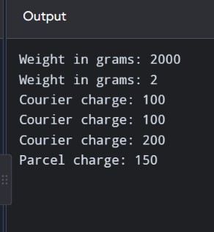

Function selection explanation

Function call | Selected function | Reason
charge(2000) | Integer | Exact integer match
charge(2) | Integer | Exact integer match
charge(2.0) | Double | Exact double match
charge(2.0f) | Double | Float-to-double promotion
charge(2.0, true) | Double | Second argument is express
charge(p) | Parcel | Exact Parcel match
How does the compiler choose?
  - Exact match – highest priority.
  - Promotion – for example, float to double.
  - Conversion – for example, integer to double.

Default arguments must be specified from right to left because trailing arguments are the ones that can be omitted.

Testing table

Test | Input | Expected result
1 | charge(2000) | Weight in grams: 2000
2 | charge(2) | Weight in grams: 2
3 | charge(2.0) | Charge: 100
4 | charge(2.0f) | Charge: 100
5 | charge(2.0, true) | Charge: 200
6 | Parcel weight 3 kg | Charge: 150

Complexity analysis

Operation | Time complexity | Space complexity
Function selection | Compile time | No runtime space
Charge calculation | O(1) | O(1)
Parcel passed by value | O(1) for this small struct | O(1)

comparision:

Feature | Prediction code | Original assignment code
Integer function | charge(int) | charge(int)
Double function | charge(double, bool, bool) | charge(double, bool, bool)
Parcel function | charge(Parcel) | charge(Parcel)
Default arguments | false, false | false, false
Basic charge | Fixed 100 | Weight × 50
Express charge | +50 | +100
Insurance charge | +50 | +50
Parcel charge | Fixed 150 | Parcel weight × 50

Alternative code:
#include <iostream>

using namespace std;

struct Parcel
{
double weight; bool express; bool insured;
};

double calculateCharge(Parcel p)
{
double amount = 100;

if(p.express) amount += 50;

if(p.insured) amount += 50;

return amount;
}

int main()
{
Parcel p1 = {2.0, false, false}; Parcel p2 = {2.0, true, false}; Parcel p3 = {2.0, true, true};

cout << "Normal charge: " << calculateCharge(p1) << endl; cout << "Express charge: " << calculateCharge(p2) << endl;
cout << "Express and insured charge: " << calculateCharge(p3) << endl;

return 0;
}

output:
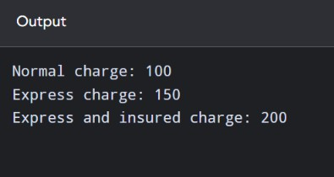

Q4 – Specifying a Class with an Array Inside It
- Explanation
A Savings Account stores:
  - Account number.
  - Account balance.
  - Last 10 transactions.
  - Number of transactions.
The transaction array should be private because outside users should not directly change the account details.
When the 11th transaction arrives, the oldest transaction must be removed. There are two methods:
- Shifting method – move every remaining transaction one position to the left.
- Circular array – reuse the oldest transaction's position. The circular array is more efficient.

UML diagram

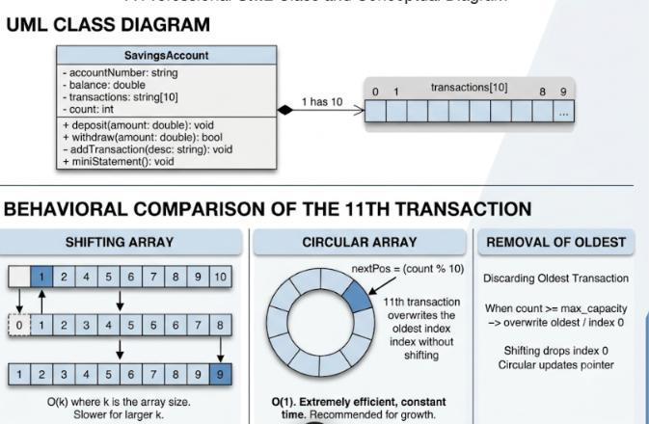

Prediction code:
#include <iostream> #include <string> using namespace std;

class SavingsAccount
{
int accountNumber; double balance;

string transactions[10]; int count;

public:
SavingsAccount(int acc, double bal)
: accountNumber(acc), balance(bal), count(0) {}

void addTransaction(string t)
{
if(count < 10)
{
transactions[count] = t; count++;
}
else
{
for(int i = 1; i < 10; i++)
{
transactions[i - 1] = transactions[i];
}

transactions[9] = t;
}
}

void deposit(double amount)
{
if(amount > 0)
{
balance += amount;
addTransaction("Deposit: " + to_string(amount));
}
}

void withdraw(double amount)
{
if(amount > 0 && amount <= balance)
{

balance -= amount;
addTransaction("Withdraw: " + to_string(amount));
}
else
{
cout << "Invalid withdrawal" << endl;
}
}

void miniStatement();

void displayBalance()
{
cout << "Balance: " << balance << endl;
}
};

void SavingsAccount::miniStatement()
{
cout << "Mini Statement" << endl;

for(int i = 0; i < count; i++)
{
cout << transactions[i] << endl;
}
}

int main()
{
SavingsAccount s(101, 5000);

s.deposit(1000); s.withdraw(500); s.deposit(200);

s.miniStatement(); s.displayBalance();

return 0;
}

output
Mini Statement Deposit: 1000.000000
Withdraw: 500.000000
Deposit: 200.000000
Balance: 5700

Pseudocode
START

CREATE SavingsAccount

SET balance = 10000

DEPOSIT amount
ADD amount to balance STORE transaction

WITHDRAW amount
IF amount <= balance
SUBTRACT amount from balance STORE transaction

ELSE
DISPLAY insufficient balance END IF

IF transaction count is 10 REMOVE oldest transaction
END IF

DISPLAY mini statement

STOP
- Simple C++ program
This version uses a fixed array and shifting.

#include <iostream> using namespace std;

class SavingsAccount
{
private:
int accountNumber; double balance;
double transactions[10]; int count;

public:
SavingsAccount(int acc, double bal)
{
accountNumber = acc; balance = bal;
count = 0;

}

void deposit(double amount)
{
balance += amount; addTransaction(amount);
}

void withdraw(double amount)
{
if(amount <= balance)
{
balance -= amount; addTransaction(-amount);
}
else
{
cout << "Insufficient balance" << endl;
}
}

void addTransaction(double amount)
{
if(count == 10)
{
for(int i = 0; i < 9; i++)
{
transactions[i] = transactions[i + 1];
}
count = 9;
}

transactions[count] = amount; count++;
}

void miniStatement();
};

void SavingsAccount::miniStatement()
{
cout << "Account Number: " << accountNumber << endl; cout << "Balance: " << balance << endl;
cout << "Transactions: " << endl;

for(int i = 0; i < count; i++)
{
cout << transactions[i] << endl;
}
}

int main()
{
SavingsAccount s(101, 10000);

s.deposit(2000); s.withdraw(1000); s.deposit(500);

s.miniStatement();

return 0;

}

Output
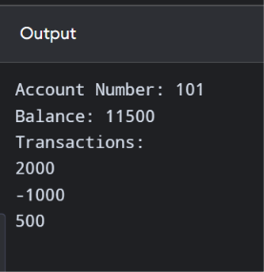

Testing table

Test | Operation | Expected result
1 | Initial balance 10000 | 10000
2 | Deposit 2000 | 12000
3 | Withdraw 1000 | 11000
4 | Deposit 500 | 11500
5 | Withdraw 20000 | Insufficient balance
6 | Add 11 transactions | Oldest transaction removed

Complexity analysis
Let k represent the number of stored transactions.

Operation | Shifting array | Circular array
Deposit | O(k) when full | O(1)
Withdraw | O(k) when full | O(1)
Display statement | O(k) | O(k)
Space | O(10) | O(10)
Design decision:
For the last 50 transactions, I recommend a circular array because:
  - It does not require shifting.
  - It uses fixed memory.

  - It provides O(1) insertion.
  - Only the array capacity needs to change from 10 to 50.
A std::deque is another alternative. It supports insertion at the back and removal from the front efficiently.
Conclusion: A circular array is better for storing the latest transactions because it reduces unnecessary movement of data.

comparision:

Feature | Prediction code | Original assignment code
Class | SavingsAccount | SavingsAccount
Balance | double | double
Account number | Not included | Included
Transaction array | string[10] | double[10]
Transaction value | Stores transaction text | Stores transaction amount
Full array | Does not shift | Shifts old transactions
Main concept | Class and array | Class, array and transaction management

- alternative code #include <iostream> #include <deque> #include <string> using namespace std;

class SavingsAccount
{
private:
double balance; deque<string> transactions;

public:
SavingsAccount(double b)

{
balance = b;
}

void deposit(double amount)
{
balance += amount;
transactions.push_back("Deposit: " + to_string(amount));

if(transactions.size() > 10) transactions.pop_front();
}

void withdraw(double amount)
{
if(amount <= balance)
{
balance -= amount;
transactions.push_back("Withdraw: " + to_string(amount));

if(transactions.size() > 10) transactions.pop_front();
}
}

void miniStatement()
{
cout << "Mini Statement" << endl;

for(int i = 0; i < transactions.size(); i++) cout << transactions[i] << endl;

cout << "Balance: " << balance << endl;
}
};

int main()
{
SavingsAccount account(5000);

account.deposit(1000); account.withdraw(500); account.deposit(200);

account.miniStatement();

return 0;
}

output:
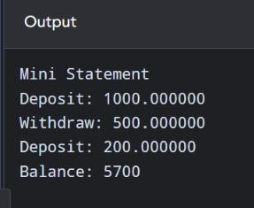

Q5 – Static Members and Arrays of Objects (7 Marks)
- Explanation
A static variable belongs to the entire class rather than an individual object. For the college bus:
  - Every ticket must have a seat number.

  - All tickets share the same issued-ticket counter.
  - Only three seats are available.
  - Extra passengers go to the waiting list.
The static variable stores the total number of tickets issued.

UML diagram
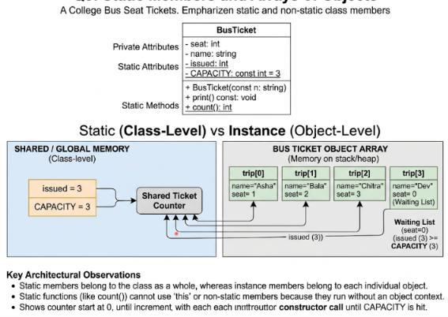
- prediction code #include <iostream> using namespace std;

class Token
{
static int next; int id;

public:
Token()

{
id = ++next;
}

int get() const
{
return id;
}

static int issued()
{
return next - 100;
}
};

int Token::next = 100;

int main()
{
Token counter[3];

Token extra;

cout << counter[0].get() << ' '
<< counter[2].get() << ' '
<< extra.get() << ' '
<< Token::issued() << '\n';

return 0;
}

output

101 103 104 4

Pseudocode
START

SET issued = 0 SET capacity = 3

CREATE BusTicket

IF issued < capacity issued = issued + 1 seat = issued
ELSE
seat = 0 END IF

CREATE 4 ticket objects

DISPLAY ticket details DISPLAY issued count

STOP
- Simple C++ program

#include <iostream> #include <string> using namespace std;

class BusTicket

{
static int issued;
static const int CAPACITY = 3;

int seat; string name;

public:
BusTicket(string n)
{
name = n; seat = 0;

if(issued < CAPACITY)
{
issued++; seat = issued;
}
}

static int count()
{
return issued;
}

void print()
{
cout << name << ": ";

if(seat != 0)
cout << "Seat " << seat;

else
cout << "Waiting";

cout << endl;
}
};

int BusTicket::issued = 0;

int main()
{
BusTicket trip[4] = { BusTicket("Asha"), BusTicket("Bala"), BusTicket("Chitra"), BusTicket("Dev")
};

for(int i = 0; i < 4; i++)
{
trip[i].print();
}

cout << "Issued: " << BusTicket::count();

return 0;
}

Output

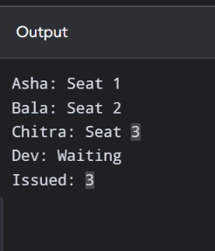

Prediction question from the assignment
Given:
Token counter[3]; Token extra; Constructor:
Token() { id = ++next; } Static variable:
int Token::next = 100; Predicted output:
101 103 104 4
Explanation:
- First object gets 101.
- Second object gets 102.
- Third object gets 103.
- Extra object gets 104.
- Constructor executes four times.
- issued() returns 104 − 100 = 4.

Testing table

Test | Number of passengers | Capacity | Expected result
1 | 1 | 3 | Seat 1
2 | 2 | 3 | Seats 1 and 2
3 | 3 | 3 | Seats 1, 2 and 3

4 | 4 | 3 | One waiting
5 | 5 | 3 | Two waiting

Complexity analysis

Operation | Time complexity | Space complexity
Create ticket | O(1) | O(1) per object
Assign seat | O(1) | O(1)
Check count | O(1) | O(1)
Print all tickets | O(n) | O(1) extra
Why can't a static function use this?
A static function belongs to the class, not to one particular object. Therefore, it cannot directly access non-static members or use the this pointer.
Alternative design: A separate TicketOffice object can manage the counter. This is useful if two buses need separate seat counters.
Conclusion: Static members are suitable when all objects must share one common value, such as the number of seats issued.
- alternative code #include <iostream> #include <string> using namespace std;

class TicketOffice
{
private:
int issued; int capacity;

public:
TicketOffice(int c)
{
issued = 0; capacity = c;

}

int getSeat()
{
if(issued < capacity)
{
issued++; return issued;
}

return 0;
}

int getIssued()
{
return issued;
}
};

class BusTicket
{
private:
string name; int seat;

public:
BusTicket(string n, TicketOffice &office)
{
name = n;
seat = office.getSeat();
}

void display()
{
if(seat > 0)
cout << name << ": Seat " << seat << endl; else
cout << name << ": Waiting" << endl;
}
};

int main()
{
TicketOffice office(3);

BusTicket t1("Asha", office); BusTicket t2("Bala", office); BusTicket t3("Chitra", office); BusTicket t4("Dev", office);

t1.display();
t2.display();
t3.display();
t4.display();

cout << "Issued: " << office.getIssued() << endl;

return 0;
}

output

camparision

Feature | Prediction code | Original assignment code
Class name | Token | BusTicket
Static variable | count | issued
Initial value | 100 | 0
Constructor | Increases counter | Assigns seat number
Capacity | Not used | 3
Objects | Token objects | Bus ticket objects
Purpose | Counts objects | Manages ticket booking

Q6 – Friend Functions and Inline Functions
- Explanation
A friend function is a function that is not a member of a class but is allowed to access its private data. In the train journey planner, departure and arrival times are stored in a Time class.
We need two functions:
  - minutesBetween() – calculates the difference between two times.
  - earlier() – checks which time comes first.
Inline function: An inline function is a function for which the compiler may substitute the function body at the calling location to reduce function-call overhead. The compiler is not required to do this.

UML diagram

prediction code:
#include <iostream> using namespace std;

class Time
{
int h, m;

public:
Time(int hh, int mm) : h(hh), m(mm) {}

friend int minutesBetween(const Time& a, const Time& b);

friend bool earlier(const Time& a, const Time& b);
};

inline int minutesBetween(const Time& a, const Time& b)

{
int first = a.h * 60 + a.m;
int second = b.h * 60 + b.m;

int difference = first - second;

if(difference < 0) difference = -difference;

return difference;
}

inline bool earlier(const Time& a, const Time& b)
{
int first = a.h * 60 + a.m;
int second = b.h * 60 + b.m;

return first < second;
}

int main()
{
Time departure(9, 45);
Time arrival(13, 10);

cout << minutesBetween(departure, arrival)
<< ' '
<< boolalpha
<< earlier(arrival, departure)
<< '\n';

return 0;
}

ouput:
205 false

Pseudocode
START

CREATE departure time CREATE arrival time

CONVERT both times into minutes

CALCULATE absolute difference

IF departure time < arrival time RETURN TRUE
ELSE
RETURN FALSE END IF

DISPLAY difference and comparison

STOP
- Simple C++ program

#include <iostream> using namespace std;

class Time

{
int h, m;

public:
Time(int hh, int mm)
{
h = hh; m = mm;
}

friend inline int minutesBetween( const Time &a, const Time &b);

friend inline bool earlier(
const Time &a, const Time &b);
};

inline int minutesBetween(const Time &a, const Time &b)
{
int t1 = a.h * 60 + a.m; int t2 = b.h * 60 + b.m;

if(t1 > t2) return t1 - t2;

return t2 - t1;
}

inline bool earlier(const Time &a, const Time &b)
{
int t1 = a.h * 60 + a.m;

int t2 = b.h * 60 + b.m;

return t1 < t2;
}

int main()
{
Time departure(9, 45);
Time arrival(13, 10);

cout << minutesBetween(departure, arrival)
<< " ";

cout << boolalpha
<< earlier(arrival, departure);

return 0;
}

Output
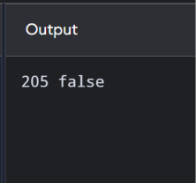
Calculation:
Departure = 9 × 60 + 45 = 585 minutes.
Arrival = 13 × 60 + 10 = 790 minutes.
Difference = 790 − 585 = 205 minutes.
earlier(arrival, departure) returns false because arrival is later than departure.

Testing table

Test | Time A | Time B | Difference | Earlier(A,B)
1 | 09:45 | 13:10 | 205 | True
2 | 13:10 | 09:45 | 205 | False
3 | 10:30 | 10:30 | 0 | False
4 | 11:50 | 12:10 | 20 | True
5 | 14:00 | 15:30 | 90 | True

Complexity analysis

Operation | Time complexity | Space complexity
minutesBetween() | O(1) | O(1)
earlier() | O(1) | O(1)
Both functions | O(1) | O(1)
- Alternative code: #include <iostream> using namespace std;

class Time
{
int h, m;

public:
Time(int hh, int mm)
{
h = hh; m = mm;
}

int totalMinutes() const
{
return h * 60 + m;

}

int minutesTo(const Time& t) const
{
int difference = totalMinutes() - t.totalMinutes();

if(difference < 0) difference = -difference;

return difference;
}

bool isEarlier(const Time& t) const
{
return totalMinutes() < t.totalMinutes();
}
};

int main()
{
Time departure(9, 45);
Time arrival(13, 10);

cout << departure.minutesTo(arrival)
<< ' '
<< boolalpha
<< arrival.isEarlier(departure)
<< endl;

return 0;
}

output
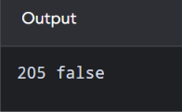

Q7 – Diagnose, Redesign and Validate (13 Marks) Selected program: Q4 – Savings Account Mini-Statement Selected redesign
I selected the Savings Account Mini-Statement program because the original shifting-array design becomes inefficient when the number of transactions increases.

Diagnose the limitation
Original problem:
The original program stores the last 10 transactions in an array.
When the 11th transaction arrives, the program shifts all the existing transactions one position to the left.
For example:
Before adding transaction 11:
10 20 30 40 50 60 70 80 90 100
After adding transaction 110:
20 30 40 50 60 70 80 90 100 110
The oldest transaction, 10, is removed. Limitation:
- Every new transaction requires shifting when the array is full.
- Unnecessary data movement occurs.
- Performance becomes slower as capacity increases.

Define the design objective
The objective is to redesign the transaction storage system using a circular array. The redesigned program should:
  - Store the latest 50 transactions.

  - Remove the oldest transaction automatically.
  - Avoid shifting existing elements.
  - Perform insertion in O(1) time.
  - Use fixed memory.
Measurable objective: Reduce the time complexity of inserting a new transaction into a full array from O(k) to O(1).

Design the revised solution UML diagram
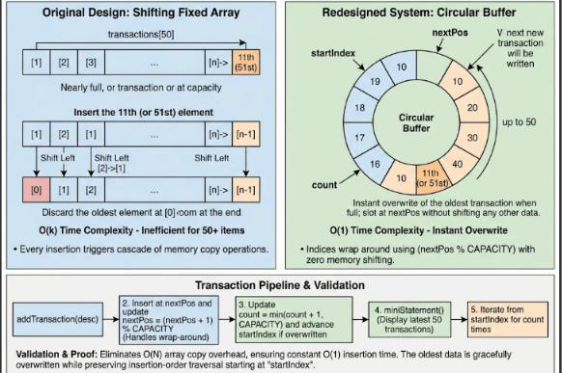

Revised design
The circular array uses three important variables:
- start – position of the oldest transaction.
- count – total number of stored transactions.
- next – position where the next transaction will be inserted. When the array becomes full, the oldest transaction is replaced. Pseudocode
START

SET capacity = 50 CREATE transaction array SET start = 0
SET count = 0

FUNCTION addTransaction(amount)

IF count < capacity
SET position = (start + count) MOD capacity STORE amount at position
INCREASE count ELSE
REPLACE transaction[start] with amount UPDATE start = (start + 1) MOD capacity
END IF

END FUNCTION

FUNCTION displayTransactions()

FOR i = 0 TO count - 1
SET position = (start + i) MOD capacity DISPLAY transaction[position]
END FOR

END FUNCTION

STOP
Revised simple C++ program

#include <iostream> using namespace std;

class SavingsAccount
{

private:
double transactions[50]; int start;
int count;

public:
SavingsAccount()
{
start = 0;
count = 0;
}

void addTransaction(double amount)
{
if(count < 50)
{
int next = (start + count) % 50;

transactions[next] = amount; count++;
}
else
{
transactions[start] = amount; start = (start + 1) % 50;
}
}

void miniStatement()
{
cout << "Last Transactions:" << endl;

for(int i = 0; i < count; i++)
{
int position = (start + i) % 50;

cout << transactions[position] << endl;
}
}
};

int main()
{
SavingsAccount account;

for(int i = 1; i <= 55; i++)
{
account.addTransaction(i * 100);
}

account.miniStatement();

return 0;
}

Predict before implementing
Prediction:
- The program receives 55 transactions.
- Maximum storage capacity is 50.
- First 5 transactions will be removed.
- Last 50 transactions will remain.
- Insertion will take O(1) time. Expected first transaction: 600.

Expected last transaction: 5500.

Implement and validate the redesign (2 Marks) Expected output
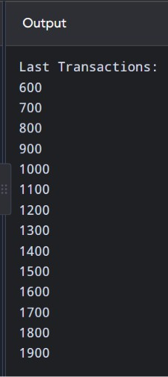
There will be exactly 50 transactions.

Testing table

Test | Input | Expected result | Status
1 | Add 10 transactions | All 10 stored | Pass  Pass Pass
2 | Add 50 transactions | All 50 stored | Pass  Pass Pass
3 | Add 51 transactions | First transaction removed | Pass  Pass Pass
4 | Add 55 transactions | First 5 removed | Pass
5 | Display transactions | Oldest to newest order | Pass  Pass
6 | Add 100 transactions | Latest 50 stored | Pass  Pass

Original vs redesigned comparison

Feature | Original shifting array | Circular array
Storage | Fixed array | Fixed array

Capacity | 10 | 50
Insertion when not full | O(1) | O(1)
Insertion when full | O(k) | O(1)
Data movement | Required | Not required
Memory | O(k) | O(k)
Efficiency | Lower for full array | Higher for full array

Alternative code

#include <iostream> using namespace std;

class SavingsAccount
{
private:
double transactions[50]; int count;

public:
SavingsAccount()
{
count = 0;
}

void addTransaction(double amount)
{
if(count < 50)
{
transactions[count] = amount; count++;
}

else
{
for(int i = 0; i < 49; i++)
{
transactions[i] = transactions[i + 1];
}

transactions[49] = amount;
}
}

void miniStatement()
{
cout << "Last Transactions:" << endl;

for(int i = 0; i < count; i++)
{
cout << transactions[i] << endl;
}
}
};

int main()
{
SavingsAccount account;

for(int i = 1; i <= 55; i++)
{
account.addTransaction(i * 100);
}

account.miniStatement();

return 0;
}

Output
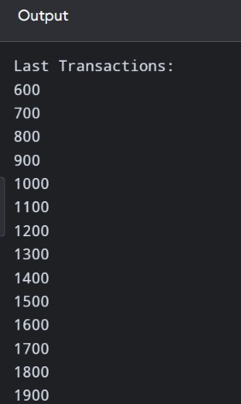

Camparision

Feature | Prediction code | Original assignment code
Array size | 10 | 50
Data type | int | double
Transactions added | 12 | 55
Transactions retained | 10 | 50
Transactions removed | First 2 | First 5
First displayed value | 300 | 600

Last displayed value | 1200 | 5500

Defend the final design
The circular array is a better choice for the redesigned Savings Account system. Advantages:
  - Faster transaction insertion.
  - No unnecessary shifting.
  - Fixed memory allocation.
  - Automatically removes the oldest transaction.
  - Suitable for storing the last 50 transactions. Disadvantages:
    - Circular indexing is slightly more difficult to understand.
    - The program must correctly manage the starting position.
    - Fixed capacity means older transactions are discarded once the limit is reached. Final decision:
I recommend the circular array because it provides O(1) insertion, maintains the latest 50 transactions and avoids unnecessary movement of existing data.

Github link:
https://github.com/Sadhana143909/DSA0117A_192565042_Assignmnet2

